**NAME: kanaka Ravi**

**BATCH: TE-BN002**

**PROJECT:** Sales Popular Marketplace Data

**OBJECTIVE :-**

The objective of this project is to analyse and interpret the online sales data to uncover actionable business insights that can drive strategic decision-making. Specifically, the project aims to:

* Evaluate overall sales performance across time periods.
* Identify top-performing products and product categories.
* Which regions or cities contribute most to sales
* Which payment method has highest revenue?
* Identify month wise revenue generation by products?
* Give me a meaningfully insights form this data.
* Create interactive dash bord from data.

**COLLECTION DATA:**

This data collect from Kaggle data sets and it is well maintained and no null value, duplicates, no errors after that I am import data into power query and check all data (rows ,columns) it is well prepared for the analysis .and it has a 9 columns and 240 rows, To analysis sales performance This dataset provides a comprehensive overview of sales transactions across different product categories. Each row represents a single transaction with detailed information such as the order ID, date, category, product name, quantity sold, unit price, total price, region, and payment method.

* **Order ID:** Unique identifier for each sales order.
* **Date:** Date of the sales transaction.
* **Category:** Broad category of the product sold (e.g., Electronics, Home Appliances, Clothing, Books, Beauty Products, Sports).
* **Product Name:** Specific name or model of the product sold.
* **Quantity:** Number of units of the product sold in the transaction.
* **Unit Price:** Price of one unit of the product.
* **Total Price:** Total revenue generated from the sales transaction (Quantity * Unit Price).
* **Region:** Geographic region where the transaction occurred (e.g., North America, Europe, Asia).
* **Payment Method:** Method used for payment (e.g., Credit Card, PayPal, Debit Car).

**Data Cleaning :**

This data collect from Kaggle data sets and it is well maintained and no null values, duplicates, no errors after that I am import data into power query and check all data (rows, columns) it is well prepared for the analysis.

**Analysing the Data:**

Load and clean the data, Convert date strings to datetime objects, Aggregate revenue and sales by:

* Year and month
* Product category
* Region
* Visualize trends (e.g., bar charts, line graphs)
* Top 5 products by generating revenue
* Revenue method by payment mode
* Summarized data by pivot table
* Above the steps are followed for analyse the data . . and it is helps to create dashboard on power bi

**Data Visualization**:

a visualization report based on your sales dataset:

**Total Revenue by Product Category**:

* Product revenue generate by electronics category (69k) & Home &kitchen generate (51k)
* Beauty Products and Sports contribute the least.

**Transaction Count by Payment Method**:

* Through credit card the highest revenue generate
* Pay pal has second in revenue generation

**Total Revenue by Region**:

* North America has 41.09% revenue
* Europe has 30.5% revenue
* Asia has 28.41% revenue

**Top 5 products**

* **1. cookware set** **2. blender 3. smartphone 4. Non - fiction 5. sneakers**

**Monthly Revenue Trend**:

* Revenue fluctuates significantly over time, with spikes in late 2020- 2025

**Creating dashboard:**

* After the data summarizing a dashboard created by using power bi
* Using donut chart ,KPI s, slicers, bar charts, funnel cart, line chat

**Presenting the Data**

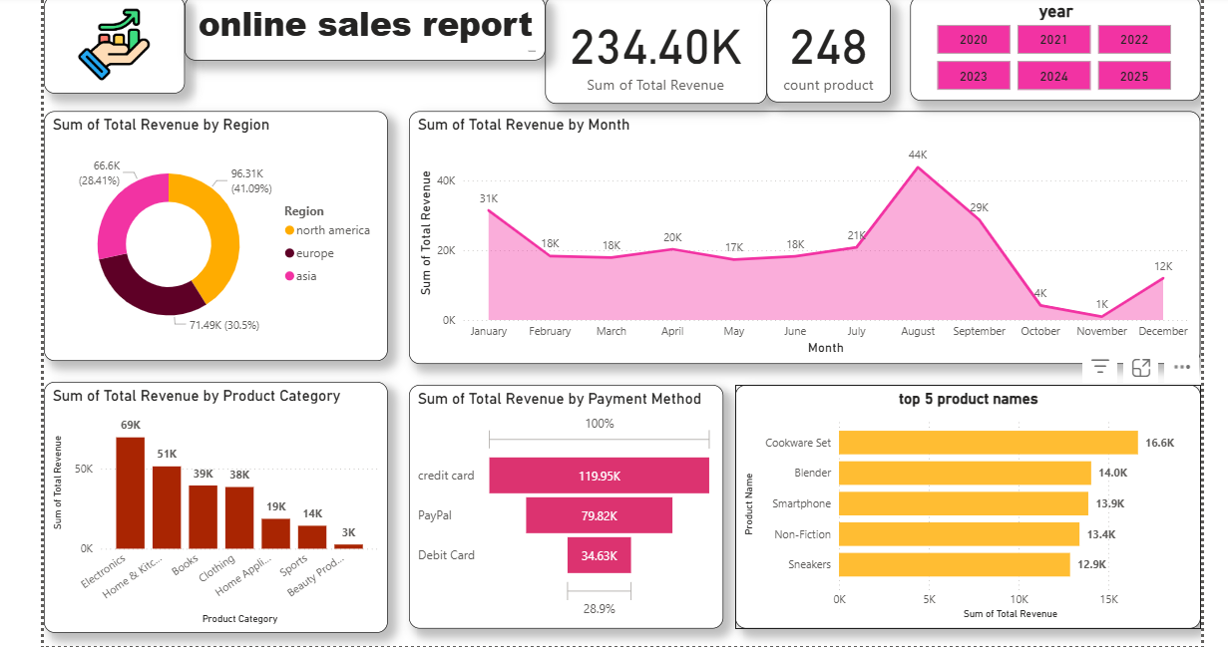

**Key Insights and Recommendations**

Insights:

1. Electronics dominate sales, contributing over one-third of total revenue
2. Credit cards are the preferred payment method for high-value purchases
3. North America has the highest average order value
4. August showed the strongest sales performance

**Recommendations**:

1. **Increase marketing focus** on Electronics and Home Appliances categories
2. **Expand credit card promotions** to encourage larger purchases
3. **Target North American customers** with premium product offer
4. **Explore growth opportunities** in the Asian market where AOV is lowest

**Conclusion**

The online sales data reveals strong performance in electronics and home appliances, with consistent monthly growth throughout the period. The business should capitalize on its strengths in North America while exploring ways to increase average order values in other regions. Payment method preferences indicate opportunities to optimize the checkout process for credit card users.

**Report prepared by:** KANAKA RAVI  
**Date:**   
**Data period:**